Redlining in Fayetteville, North Carolina
Federal Housing Policy, Local Segregation, and the Long Reach of Unequal Investment
A historically responsible educational report
Prepared for public-facing historical and civic education
━━━━━━━━━━━━━━━━━━━━━━━━━━━━━━━━━━━━
Fayetteville, North Carolina
July 2026

Table of Contents
Introduction 3
1. Redlining and Federal Housing Policy 4
2. Fayetteville in the HOLC Record 5
3. Reading the Fayetteville Map 6
4. How Housing Discrimination Worked Locally 7
5. Long-Term Consequences 8
6. Evidence, Limitations, and Responsible Interpretation 9
Conclusion 10
Notes 11
Bibliography 12
Index 13

Introduction
Redlining was a system of neighborhood risk classification and discriminatory housing practice that helped determine where mortgage credit, insurance, public investment, and private development would flow. In the 1930s, the federal Home Owners’ Loan Corporation (HOLC) created “residential security” maps for many American cities, including Fayetteville, North Carolina. These maps graded neighborhoods from A (“Best”) to D (“Hazardous”). Race, class, housing age, land use, and the possibility of racial change were among the factors used by appraisers.¹
In Fayetteville, redlining must be understood within the larger history of Jim Crow segregation, unequal access to home financing, racially restrictive customs, neighborhood steering, uneven municipal investment, and postwar expansion connected to Fort Bragg. The surviving HOLC map does not explain every later housing disparity, but it provides direct evidence that neighborhoods were evaluated through a system that treated racial composition and racial transition as threats to property values.²
This report distinguishes between what is firmly documented and what requires further local archival research. It also includes an educational reconstruction of the historic map so readers can orient themselves to familiar areas. The reconstruction is not a substitute for the original HOLC map or the accompanying area-description sheets.

1. Redlining and Federal Housing Policy
During the Great Depression, the federal government intervened in housing finance to stabilize mortgages and expand homeownership. HOLC refinanced distressed mortgages and created a City Survey Program that evaluated urban neighborhoods. Local real-estate professionals, lenders, appraisers, and public officials supplied information that helped shape the ratings.
The four grades were commonly represented as green, blue, yellow, and red. Green and blue areas were viewed as stronger investments. Yellow areas were treated as declining. Red areas were labeled hazardous. Although the maps were not the sole cause of mortgage discrimination, they documented and reinforced a broader system in which racial identity and neighborhood composition affected access to conventional credit.³
Grade | Color | Official Label | Typical Meaning
A | Green | Best | Most favored for mortgage investment
B | Blue | Still Desirable | Generally acceptable for lending
C | Yellow | Definitely Declining | Viewed cautiously; credit often restricted
D | Red | Hazardous | Most disfavored; conventional credit difficult
The Federal Housing Administration (FHA) and private lending markets also promoted racially segregated development through underwriting rules, subdivision standards, and local practice. FHA policy historically favored new, racially homogeneous developments and often treated integration as a financial risk. The result was not merely exclusion from particular neighborhoods; it was unequal access to the long-term wealth-building benefits of low-cost, federally supported homeownership.
The Fair Housing Act of 1968 prohibited many forms of housing discrimination, and the Community Reinvestment Act of 1977 later required federally insured banks to help meet the credit needs of their entire service areas. These laws changed the legal framework, but they did not automatically erase decades of accumulated advantage and disadvantage.⁴

2. Fayetteville in the HOLC Record
Fayetteville appears in the surviving national collection of HOLC redlining materials. The University of Richmond’s Mapping Inequality project and associated geospatial repositories identify Fayetteville among the North Carolina cities for which HOLC map and area-description data survive. The record places the city within a federal system that translated local judgments about race, class, housing condition, and neighborhood change into formal investment grades.
Fayetteville’s historic urban geography is especially important. Haymount developed as an elevated residential district west of the downtown core and remains one of the city’s oldest intact residential areas. Massey Hill emerged in connection with the textile era and mill-village development. Downtown and Market Square formed the commercial and civic core. The Fayetteville State area was historically connected to Black education, residence, and institution building. These areas did not develop under equal conditions or receive equal access to mortgage capital and public investment.⁵
The military economy adds another layer. Fayetteville’s growth accelerated during and after World War II as Fort Bragg expanded. Black service members and veterans could be legally eligible for federal benefits while still confronting discriminatory lenders, appraisers, real-estate agents, and segregated housing markets. Eligibility on paper did not guarantee equal access in practice.

3. Reading the Fayetteville Map
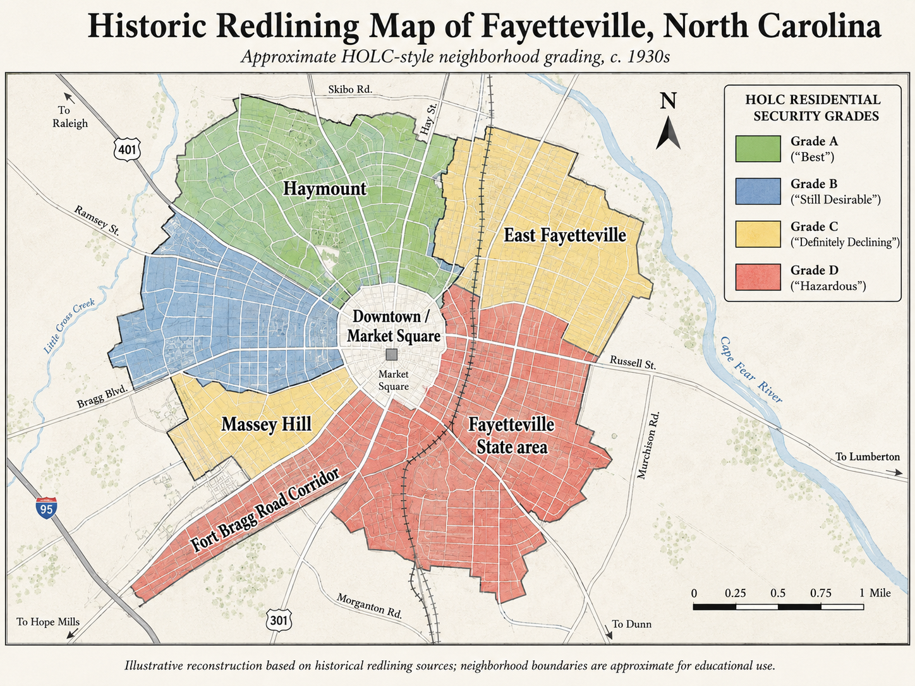
Figure 1. Educational reconstruction of historic redlining patterns in central Fayetteville. The labeled areas are approximate orientation points and should not be treated as exact HOLC boundaries.
Source note: Created for this report using the historic HOLC grading framework and Fayetteville place names. For exact boundaries, grades, and area descriptions, consult the original Fayetteville HOLC materials through Mapping Inequality and related archives.

4. How Housing Discrimination Worked Locally

Neighborhood grading
A household could be financially qualified yet still face rejection or unfavorable terms because a lender or appraiser considered the surrounding neighborhood risky.

Racial steering and restricted choice
Real-estate professionals could direct Black and white households toward different parts of the city, reducing market choice and reinforcing segregation.

Unequal mortgage access
Families excluded from conventional mortgages often relied on rentals, personal loans, installment contracts, family savings, or higher-cost arrangements that created less equity and greater risk.

Appraisal bias
When appraisals discounted properties in Black neighborhoods or treated proximity to Black residents as a negative factor, owners received less borrowing power and less wealth growth.

Public infrastructure and redevelopment
Road construction, zoning, urban renewal, drainage, utilities, and redevelopment decisions could magnify earlier patterns by concentrating burdens in politically weaker communities.

Military and veteran housing
The postwar housing boom created major wealth opportunities, but discriminatory local implementation limited equal access for Black veterans and military families.
A 2020 fair-housing analysis prepared for Fayetteville and Cumberland County concluded that barriers to fair housing persisted and included concerns about lending patterns, segregation, disability access, affordability, and unequal housing opportunity. The report also used Home Mortgage Disclosure Act data to examine conventional-loan denial patterns by income and race.⁶

5. Long-Term Consequences
The consequences of redlining are cumulative. A family that purchased a home with a low-cost mortgage in a favored neighborhood could build equity, borrow for education or business, and transfer wealth to the next generation. A similarly situated family denied that opportunity could pay rent for decades, purchase under riskier terms, or own property in a neighborhood starved of investment.
- Lower homeownership and reduced intergenerational wealth
- Slower property appreciation in historically disfavored areas
- Older housing stock and deferred maintenance
- Greater exposure to industrial, transportation, or environmental burdens
- Higher concentrations of renters and cost-burdened households
- Weaker access to mainstream banking and affordable credit
- Displacement through redevelopment, highway construction, or rising land values
National research comparing HOLC grades with modern conditions has found that many formerly redlined neighborhoods remain more likely to have lower incomes, lower homeownership, greater racial segregation, and higher exposure to environmental risks. These national findings provide a research framework, but Fayetteville-specific conclusions require neighborhood-level comparison of historic boundaries with present-day census, lending, property, health, flood, and infrastructure data.⁷

6. Evidence, Limitations, and Responsible Interpretation
The original map is a primary source, but it must be interpreted carefully. A red boundary documents an official classification, not the complete experience of every household inside it. Likewise, the absence of a red grade does not prove that discrimination was absent. Banks, insurers, landlords, developers, and public agencies could discriminate through practices not visible on the HOLC map.
Neighborhood names change over time, and modern subdivision boundaries may not match 1930s appraisal districts. Therefore, a present-day neighborhood should not be assigned a historic grade solely because it appears near a colored area on a simplified map. Exact statements should be based on the original map, area-description forms, historic plats, deeds, city directories, Sanborn maps, tax records, and local newspaper archives.
The map in this report is deliberately labeled as an illustrative reconstruction. It identifies familiar orientation areas—Haymount, Downtown/Market Square, Massey Hill, East Fayetteville, the Fayetteville State area, and the Fort Bragg Road corridor—but does not claim that every displayed boundary reproduces the federal map precisely.
A stronger local study would also investigate racially restrictive covenants, subdivision advertisements, lending records, annexation, urban-renewal projects, highway construction, school boundaries, municipal services, and the experience of Black veterans. Oral histories from long-term residents can help explain how formal policy was experienced in daily life.

Conclusion
Redlining in Fayetteville was not an isolated mapmaking exercise. It was part of a larger structure that linked race, place, credit, and public policy. The HOLC materials show how local neighborhoods were translated into investment categories during the Jim Crow era. Those categories operated alongside segregation, discriminatory lending, restricted housing choice, and unequal public investment.
The historical significance lies in the compounding effect. Mortgage credit shaped who could buy, where families could live, how quickly property appreciated, and whether one generation could transfer wealth to the next. In a military city whose residents included Black soldiers and veterans, the distance between federal promises and local access is especially important.
Understanding this history does not require claiming that every modern inequality was caused by a single 1930s map. It requires recognizing that housing markets were structured by policy and that the effects of unequal opportunity can persist long after explicitly discriminatory rules are repealed. Fayetteville’s record should therefore be studied with precision, transparency, and respect for the communities whose experiences are often missing from official documents.

Notes
1. University of Richmond, Digital Scholarship Lab, “Mapping Inequality: Redlining in New Deal America,” interactive map and archival collection, accessed July 2026.
2. Home Owners’ Loan Corporation, Residential Security Map and area-description materials for Fayetteville, North Carolina, ca. 1935–1940, as preserved in the Mapping Inequality collection and associated geospatial repositories.
3. Amy E. Hillier, “Redlining and the Home Owners’ Loan Corporation,” Journal of Urban History 29, no. 4 (2003): 394–420.
4. Federal Reserve History, “Redlining,” and U.S. Department of Housing and Urban Development, historical overview of the Fair Housing Act; see also Community Reinvestment Act materials from the Federal Reserve.
5. City of Fayetteville, Fayetteville Municipal Survey of Buildings, Sites, and Structures (2001); City of Fayetteville historic-district guidance describing Haymount and Massey Hill development.
6. City of Fayetteville and Cumberland County, Analysis of Impediments to Fair Housing Choice (2020), especially sections addressing lending, segregation, protected classes, and Home Mortgage Disclosure Act data.
7. National Community Reinvestment Coalition, HOLC “Redlining” Maps: The Persistent Structure of Segregation and Economic Inequality (2018); see also research on the modern environmental and economic correlates of historical HOLC grades.

Bibliography
City of Fayetteville. Design Guidelines for Fayetteville’s Historic Districts and Local Landmarks. Fayetteville, NC: City of Fayetteville, 2015.
City of Fayetteville. Fayetteville Municipal Survey of Buildings, Sites, and Structures. Fayetteville, NC, 2001.
City of Fayetteville and Cumberland County. Analysis of Impediments to Fair Housing Choice. Fayetteville, NC, 2020.
Federal Reserve History. “Redlining.” Federal Reserve Bank historical resource.
Hillier, Amy E. “Redlining and the Home Owners’ Loan Corporation.” Journal of Urban History 29, no. 4 (2003): 394–420.
Home Owners’ Loan Corporation. Residential Security Map and Area Descriptions for Fayetteville, North Carolina. ca. 1935–1940.
National Community Reinvestment Coalition. HOLC “Redlining” Maps: The Persistent Structure of Segregation and Economic Inequality. Washington, DC, 2018.
Nelson, Robert K., LaDale Winling, Richard Marciano, and Nathan Connolly. Mapping Inequality: Redlining in New Deal America. Digital Scholarship Lab, University of Richmond.
Rothstein, Richard. The Color of Law: A Forgotten History of How Our Government Segregated America. New York: Liveright, 2017.
U.S. Department of Housing and Urban Development. “History of Fair Housing.” Washington, DC.

Index
appraisal bias | 4, 7
Black veterans | 5, 7, 10
Community Reinvestment Act | 4
conventional mortgages | 3–4, 7–8
Downtown / Market Square | 5–6
Fayetteville State area | 5–6, 9
Federal Housing Administration (FHA) | 4
Fair Housing Act | 4
Fort Bragg | 3, 5, 7, 10
Fort Bragg Road corridor | 6, 9
Haymount | 5–6, 9
Home Owners’ Loan Corporation (HOLC) | 3–6, 9–11
housing discrimination | 3–4, 7, 9–10
Jim Crow segregation | 3, 5, 10
Mapping Inequality | 3, 5–6, 9, 11–12
Massey Hill | 5–6, 9
mortgage credit | 3–4, 7–8, 10
racial steering | 7
redlining grades | 4, 6
restrictive covenants | 3, 9
urban renewal | 3, 7–9
wealth, intergenerational | 4, 8, 10

